Implementation Summary:

The dataset selected was acquired from the UCI Machine Learning Repository (2014) and is publicly available for research. It contains data related to clients that were contacted through a marketing campaign that was phone-call based by a Portuguese Bank, to get customers to subscribe to a bank term deposit.
Output variable:
- y - did the client subscribed a term deposit? (yes/no)

This dataset has 21 columns and 41,188 rows of both numerical and non-numerical (categorical) data related to clients and the social/economic context for the bank:
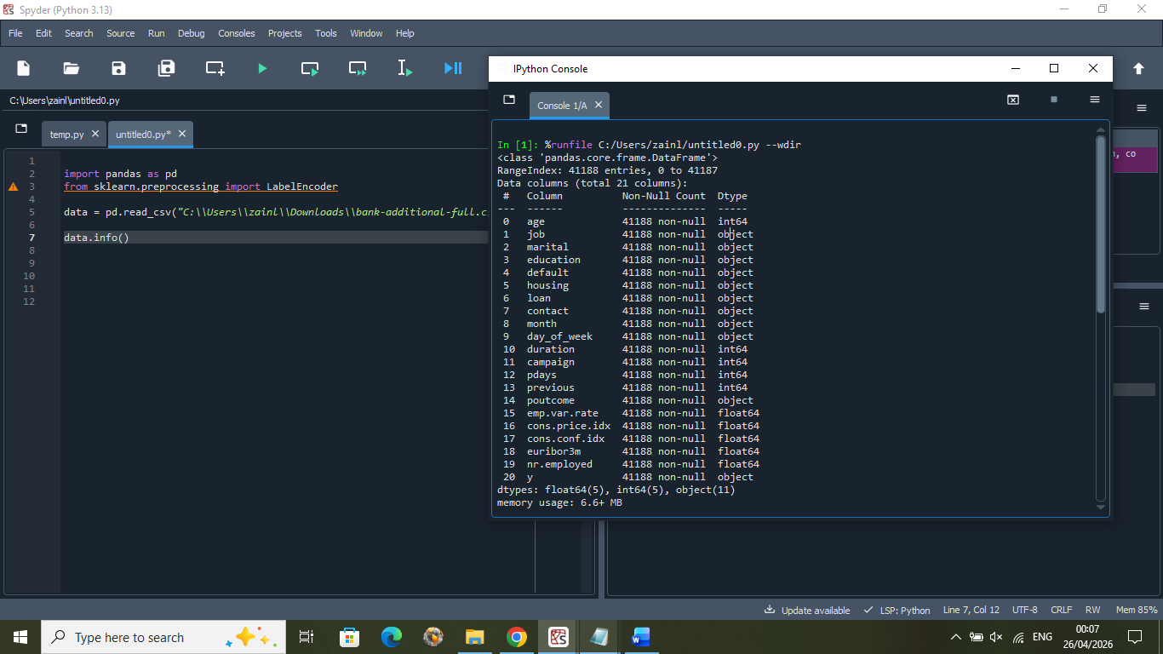

Fig 1. Investigating data using df.info()

When investigating the data, we can determine that these input variables contribute to the outcome of output variable ‘y’. Therefore, using a relevant machine learning algorithm to classify ‘y’ against the necessary inputs, we can build a model to predict the likelihood of a client subscribing to a term deposit. This is beneficial for this bank as it will allow them to target client demographics that have higher probability to open term deposits when doing future marketing campaigns, resulting in higher amounts of client subscriptions.

AI technique – Decision Tree:
The technique I have selected for this dataset is the decision tree classifier. This is a type of supervised machine learning that’s common for classification tasks and works by predicting a class label by learning a series of decision rules based on the data that is inputted. It splits the dataset step-by-step based on feature values to create decision rules based on a defined criteria. The core structure is a hierarchical tree that begins at the root node where all the data starts and the first split happens, then branches into internal nodes that are subsets of that data. This process of splitting continues down the tree recursively until the data reaches a leaf node, and no further splitting can happen, or maximum depth is reached. This is where the decision tree’s prediction is reached and the set of nodes visited is called the ‘inference path’.
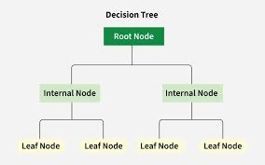

Fig. 2 Basic structure of decision tree

For the bank marketing dataset, the decision tree is suitable because:
- It can handle data of different types of both numeric and categorical

- It’s an effective model for a tabular (.csv) dataset

- It is common for classification tasks, which is the goal for this data

- The data is labelled, so a supervised learning model is required

- The relationships between the variables may be complex and non-linear, and decision trees can handle this type of data and model this

- The model is easy to interpret and explainable (white box)

Data Preparation:
Before implementing the selected AI technique, we perform preprocessing on the dataset to ensure accurate predictions and avoid any errors. We separate the data into numerical and categorical and deal with each group.

For numerical columns:
The ‘duration’ variable is dropped from the dataset, as this value is only known after a phone call ends and at which point variable ‘y’, which is we want to predict, is already known. Also, if duration is 0, then ‘y’ is obviously ‘no’. This isn’t useful for a model that wants to predict ‘y’ for future marketing campaigns, so it’s not required.
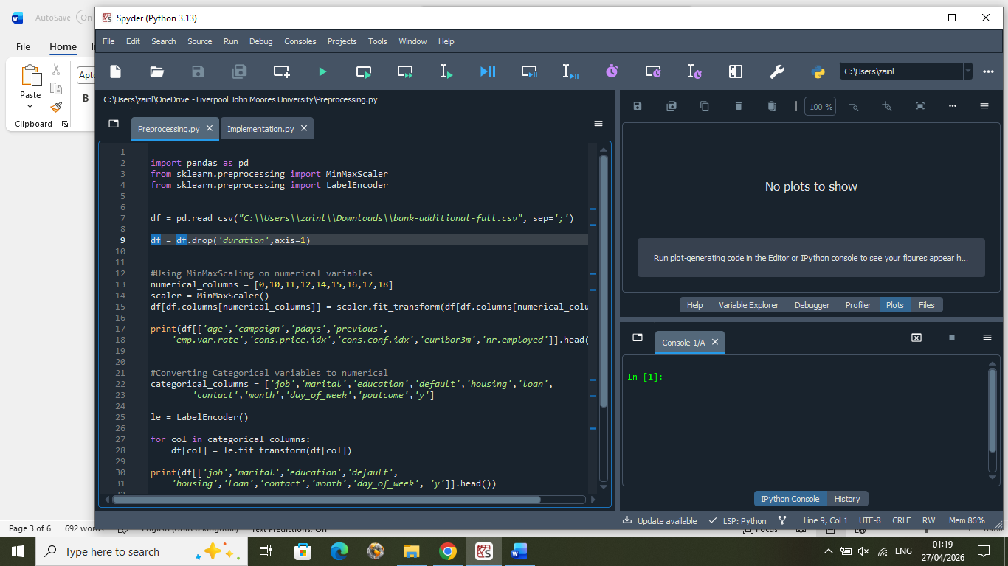

Fig. 3

For the rest of the numeric columns, we check for any null values:
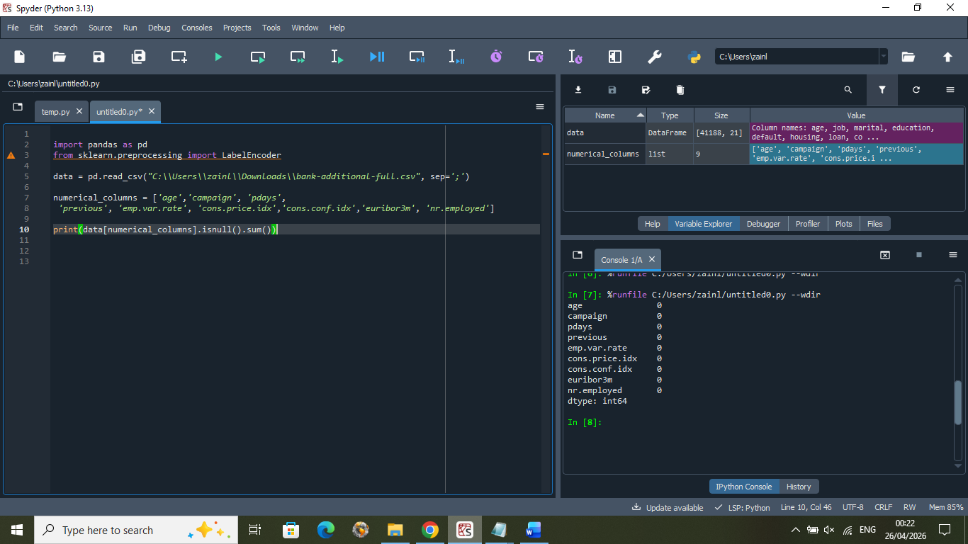

Fig. 4


Fig.5 no null values
Then creating visualisations for each column to further investigate:
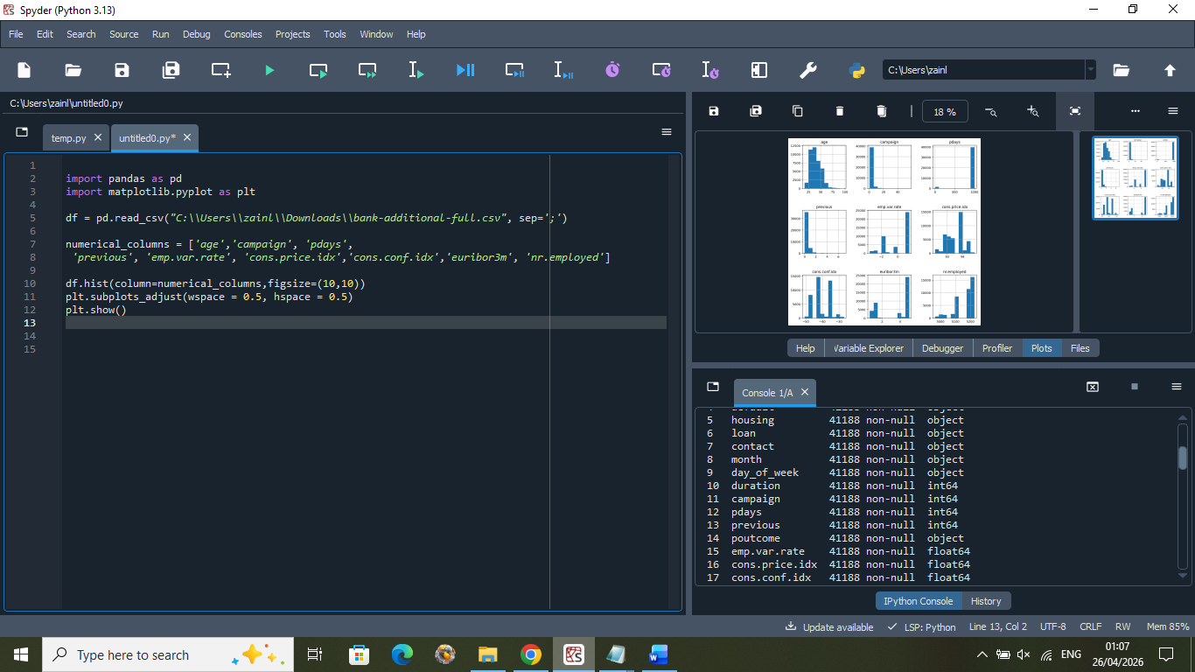

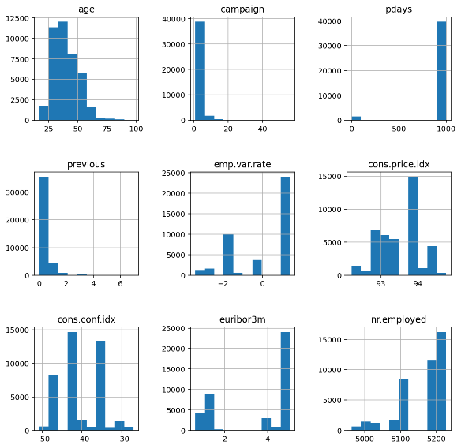

Fig. 6

From looking at the graphs and the X-axis for each in particular, we see that the range and scale of values for each column differs greatly from each other. We also see the existence of negative values. To allow all features to contribute equally to our model, we can ensure a consistent scale across all features while preserving the original distributions by using MinMaxScaler().
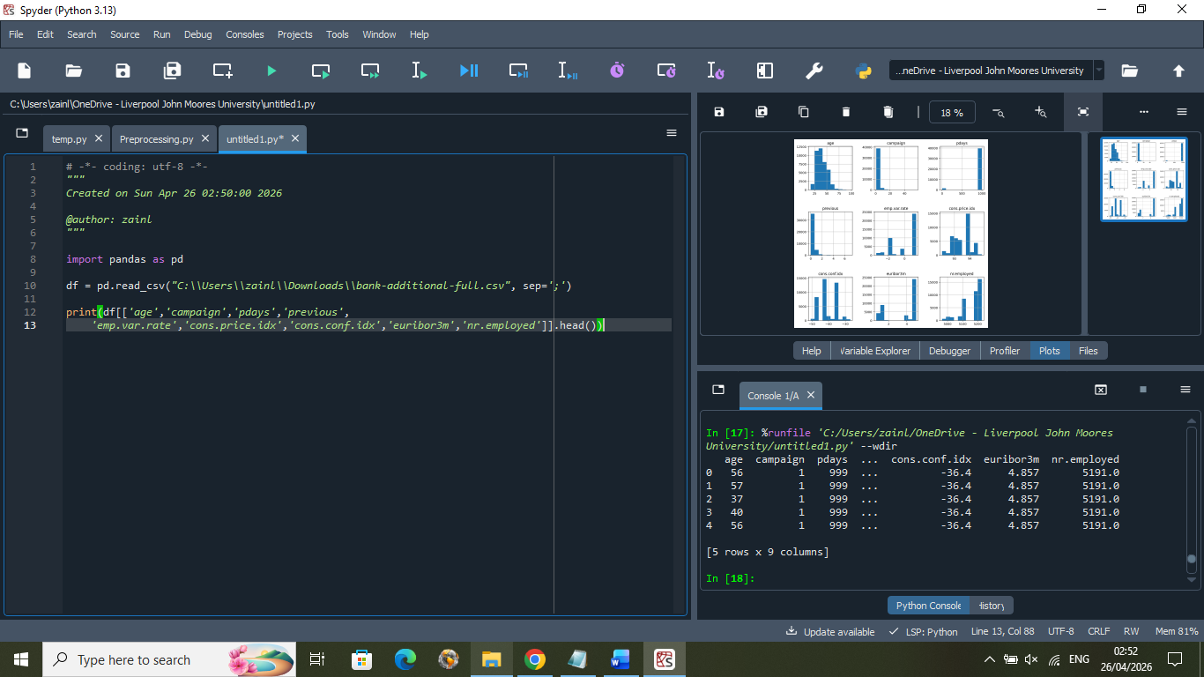

Fig. 7 numeric data before MinMaxScaler()
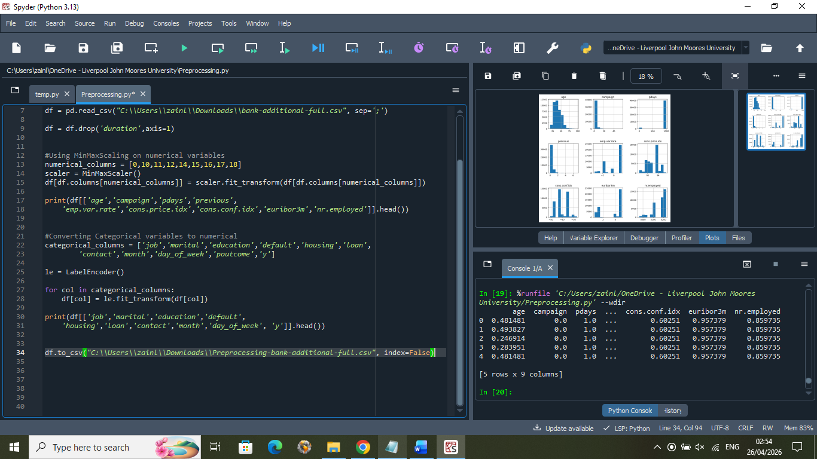

Fig.8 numeric data after MinMaxScaler()

For categorical columns:
We check for any null values in the data:
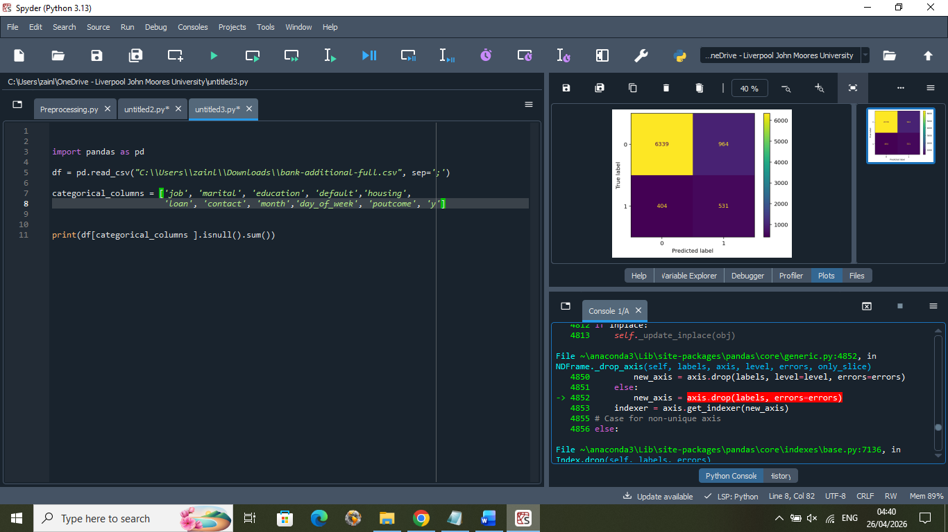

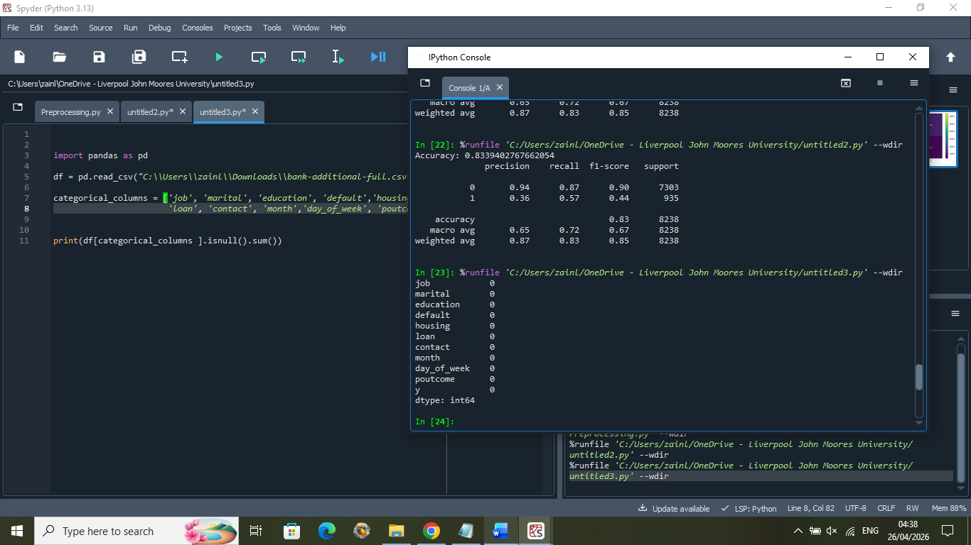

Fig.9 no null values

Looking at the categorical data, we see it’s in text format. Our machine learning model requires numeric inputs, so we need to perform encoding to convert them into numbers. We use LabelEncoder() which is more suitable for decision trees and assigns each category for categorical variables, a unique integer value.
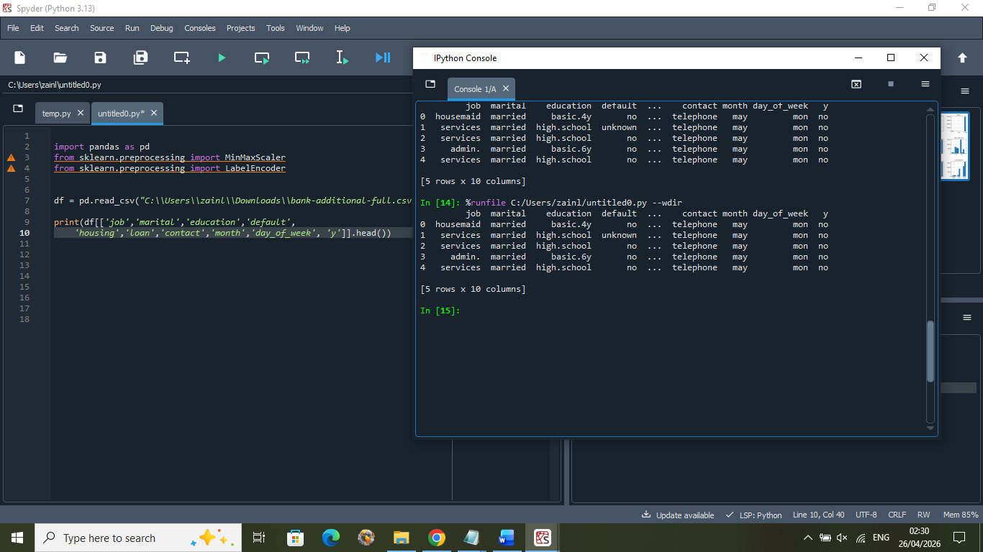

Fig. 10 categorical data before LabelEncoder()
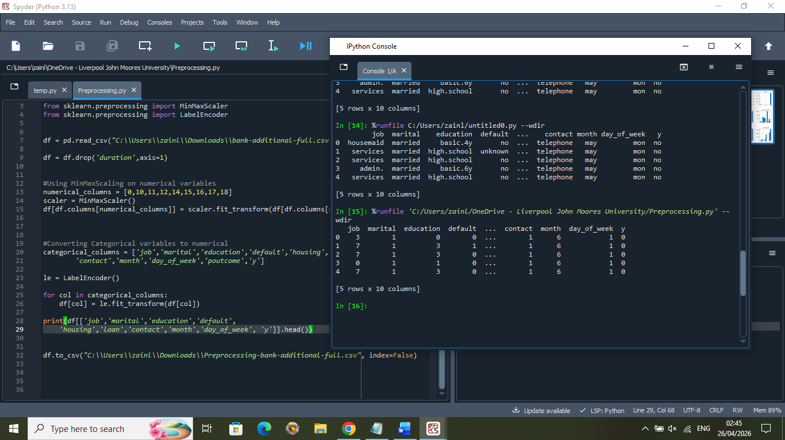

Fig. 11 categorical data after LabelEncoder()

For the frequency of yes/no for variable ‘y’, we see a class imbalance where the data is heavily skewed towards ‘no’ and the frequency of ‘yes’ is low:
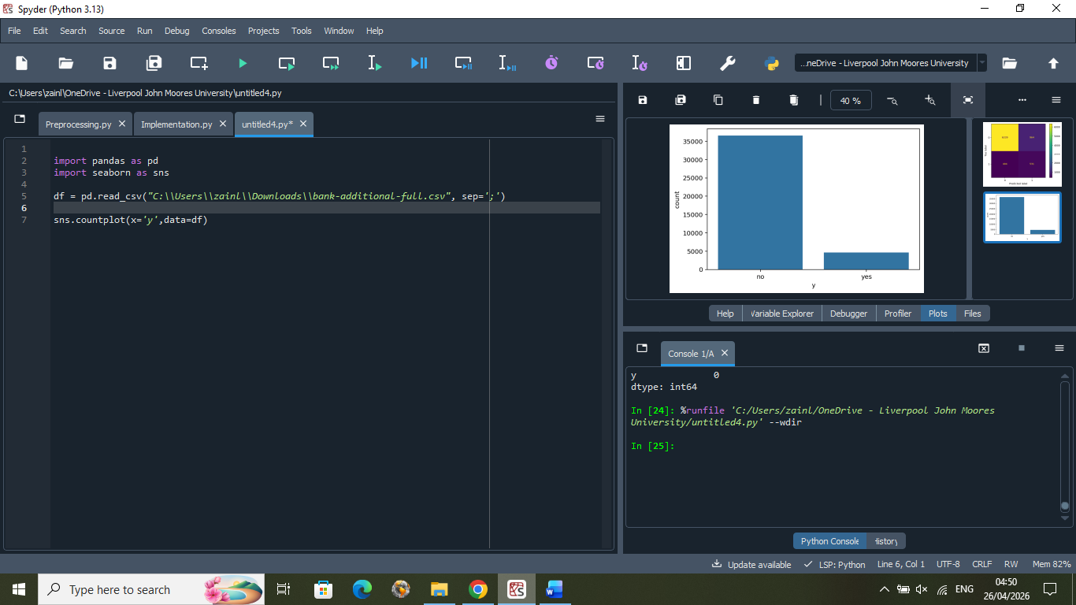

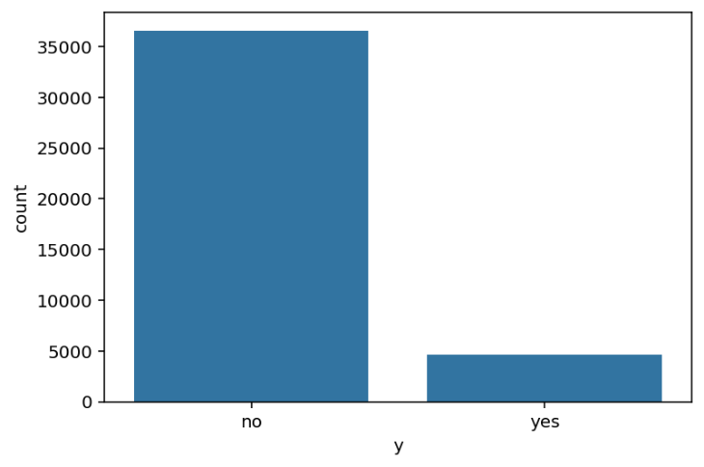

Fig. 12
This can be problematic for our decision tree model as it can lead to ‘majority class bias’ where the majority tends to be prioritised during training, and the model becomes biased towards ‘no’. It’s possible for the minority class ‘yes’ to get overlooked completely and predict ‘no’ for all clients. To amend this, the necessary adjustment is made in the Implementation.py file.

Implementation and parameter setting:
The implementation begins with loading the dataset that has been pre-processed. ‘X’ is defined to be all of the input features except ‘duration’ to evaluate splits in the decision tree, and ‘y’ to be the target variable we aim to predict.
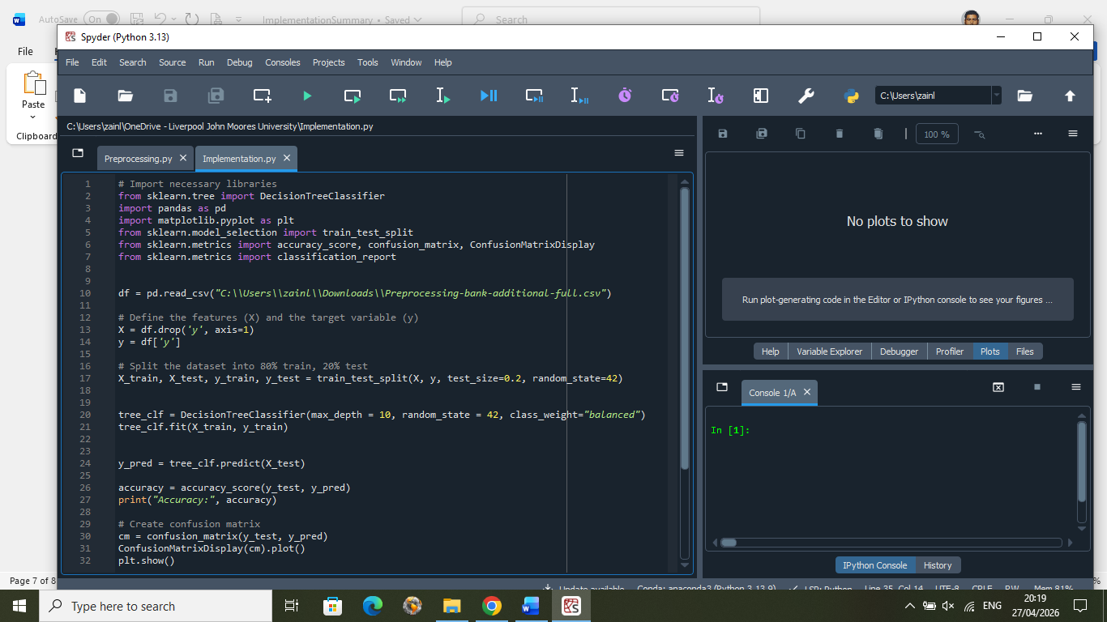

Fig. 13

The data is then split randomly, where 80% becomes the training set that is used to build the tree by learning patterns, and 20% becomes the test set that’s used to evaluate performance. ‘random_state’ is introduced to control the randomness of the split in the data to ensure that it remains constant every time the code runs. Without this, the model’s accuracy may change, so this allows for the reproducibility of results.

Fig. 14

The decision tree model is then implemented and defined to have a maximum depth of 10, to control how many splits take place from the root node to the leaf node. This is necessary as the dataset is very large and so the decision tree may become too complex and also cause ‘overfitting’ where the model matches the training set nearly exactly, leading to inaccurate predictions for the test set. ‘random_state’ is also set to control randomness for any decision splits and feature selections, to ensure the same tree is produced each execution for reproducibility.

The class imbalance for variable ‘y’ is handled here through the ‘class_weight’ parameter which ensures that the model better identifies and pays more attention to the minority class.
Fig. 15

The model then begins training where decision rules are built based upon feature splits that take place recursively until a leaf node is reached and the majority class is output for that leaf. Predictions for the ‘y’ variable are generated, and an accuracy score is output, computing the accuracy of the model’s predictions for the test set.


Fig.16

We evaluate the performance of the model using a classification report that gives key metrics such as precision, recall, F1-score and support. A confusion matrix is also plotted that breaks predictions into true positives/negatives and false positives/negatives.
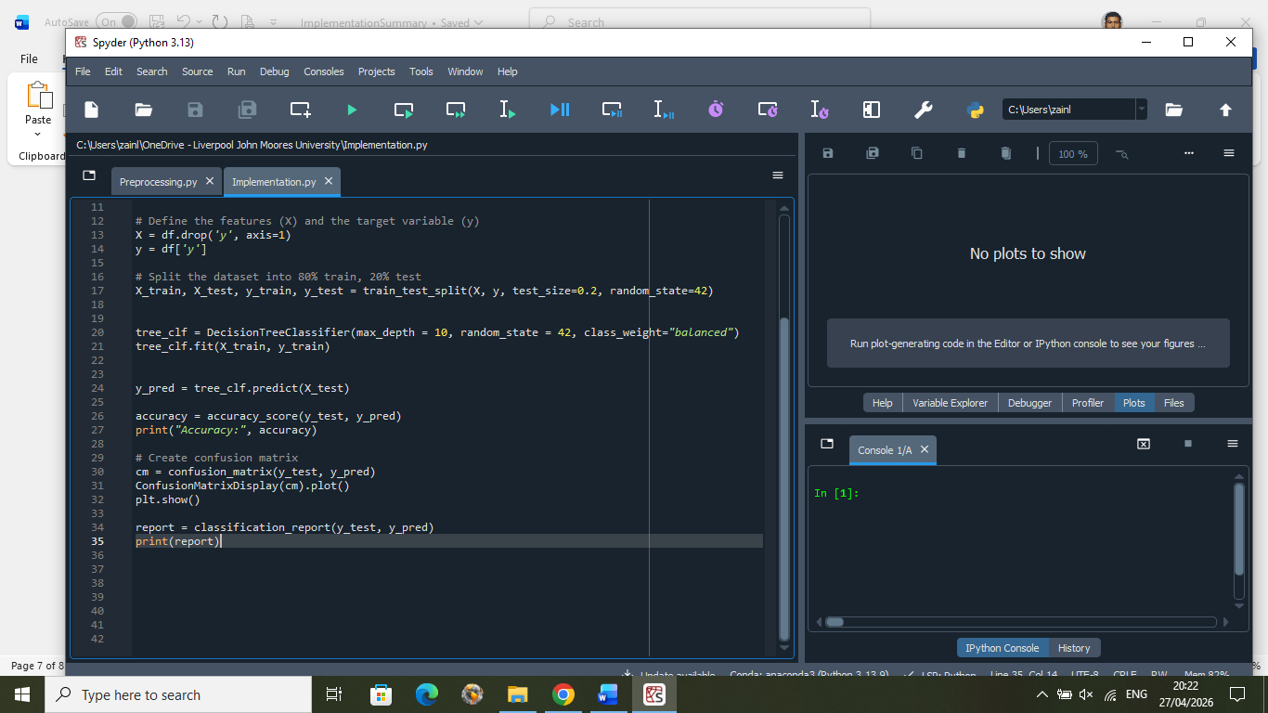

Fig. 17


Fig. 18

Evaluation results:

From reading the confusion matrix plot we find:

- True Negatives (TN) = 6339 clients predicted ‘no’, showing customers who wouldn’t subscribe were predicted correctly
- False Positives (FP) = 964 clients incorrectly predicted ‘yes’ but were actually ‘no’. This may lead to customers being contacted unnecessarily

- False Negatives (FN) = 404 clients predicted ‘no’ but actually ‘yes’. This can lead to missing potential subscribers

- True Positives (TP) = 531 clients correctly predicted ‘yes’. These are successfully identified customers who will subscribe to term deposits

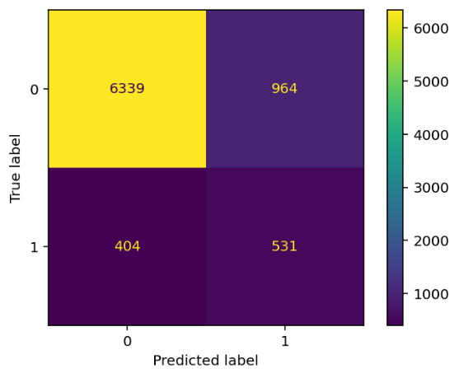

Fig. 19
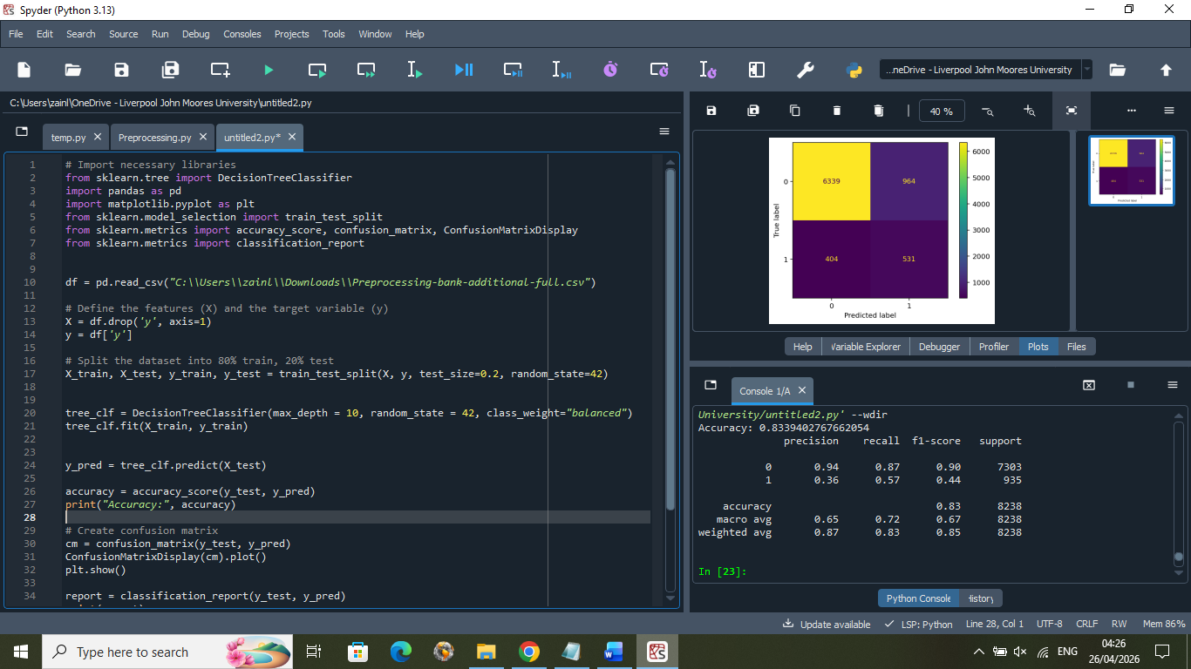

Fig. 20

For the accuracy value we find:
- Accuracy = 0.83 - this means overall predictions for ‘y’ were correct 83% of the time

From ‘0’ (no) class in the classification report:
- Precision = 0.94 – the model is correct 94% of the time when predicting ‘no’

- Recall = 0.87 - correctly identifies 87% of all actual “no” cases

- F1-score = 0.90 – combines precision and recall, showing good balance

- Support = 7303 – represents the number of instances of class 0 (‘no’) in the test dataset
This show that the model is performing very well on class 0 and is good at predicting ‘no’

From ‘1’ (yes) class in the classification report:

- Precision = 0.36 - only 36% of predicted ‘yes’ are correct indicating many false positives

- Recall = 0.57 - model finds 57% of client subscribers (True Positives)

- F1-score = 0.44 - Low balance between precision and recall

- Support = 935 - represents the number of instances of class 1 (‘yes’) in the test dataset

This shows weak overall performance for predicting ‘yes’ in this model. This is most likely due to the class imbalance between ‘yes’ and ‘no’, indicating ‘overfitting’ may have taken place, so further data preprocessing steps are required before implementation.

